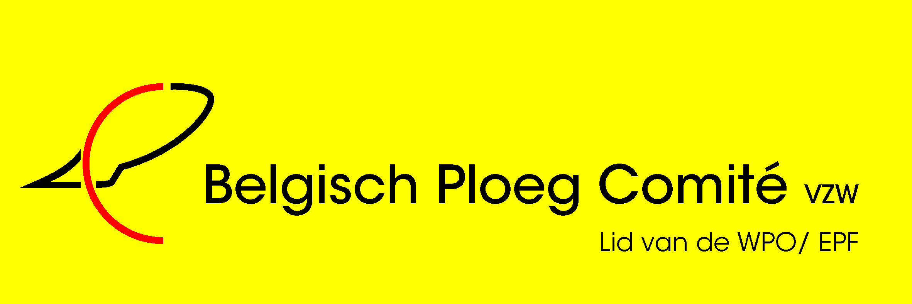
31 th European Reversible Ploughing Championships in Belgium 20th - 25th of august 2014
2440 Geel – Kleinhoefstraat 4 – Thomas More College
- Registration before 1st of may 2014 ! Please include a photo in colours of each competitor and the coach ( for the programbook )
Each country brings two national flags !

- Return to : secretary BPC : Mrs Stockman – Claeys Anne –Marie , Oosthoek 127 ,
9960 Assenede - Belgium - Telephone / fax 0032 9 344 93 90
Mobil 0032 472 40 64 90
e-mail : annemarie.claeys@telenet.be

- Participation fee : Competitor : 575 euro > 5 nights } after the 1st
Coach : 575 euro > 5 nights } of may >
Judge : 575 euro > 5 nights } 625 euro
Further guests : 675 euro > 5 nights (visits included) After the 1st of may > 725euro
Guests from friday until monday > 390 euro > 3 nights

Competitors and coaches who will arrive before 20th of august ( prepractice ) > 70 euro room and breakfast por day ; plots for practice included !

Please note the day of arrival with registration !!
Or send a mail to the secretary of the Belgian Comittee.
For this prices are included : room , breakfast , lunch on thursday, friday, saturday and sunday, diner and beer, water , wine,… with all the meals ,
festivalevening and drinks > for competitors , coach , judge and guests who pay the whole program.

- Payments ( = confirmation ) must be made no later than the 1th of may 2014
and should be send to :
Belgian Ploughing Committee ( BPC ) Anne-Marie Claeys
Oosthoek 127 - 9960 Assenede - Belgium
IBAN: BE79 7370 4167 0233
BIC : KREDBEBB
BANK CHARGES to be paid by the customer !

- If you have questions , please send a mail to annemarie.claeys@telenet.be
or to the temporary chairman Karel Van Dyck : karelvandijck@skynet.be

- If you need a tractor ? Tel Sus Echelpoels, the Belgian coach +32/475 57 96 52

We all wish you a warm welcome in Belgium !

